LORA & QLORA

As we saw about QAT this is what we will be studying about in future lessons because this is finetuning. Well, LORA stands for Low Rank Adaptation of Large Language Models.

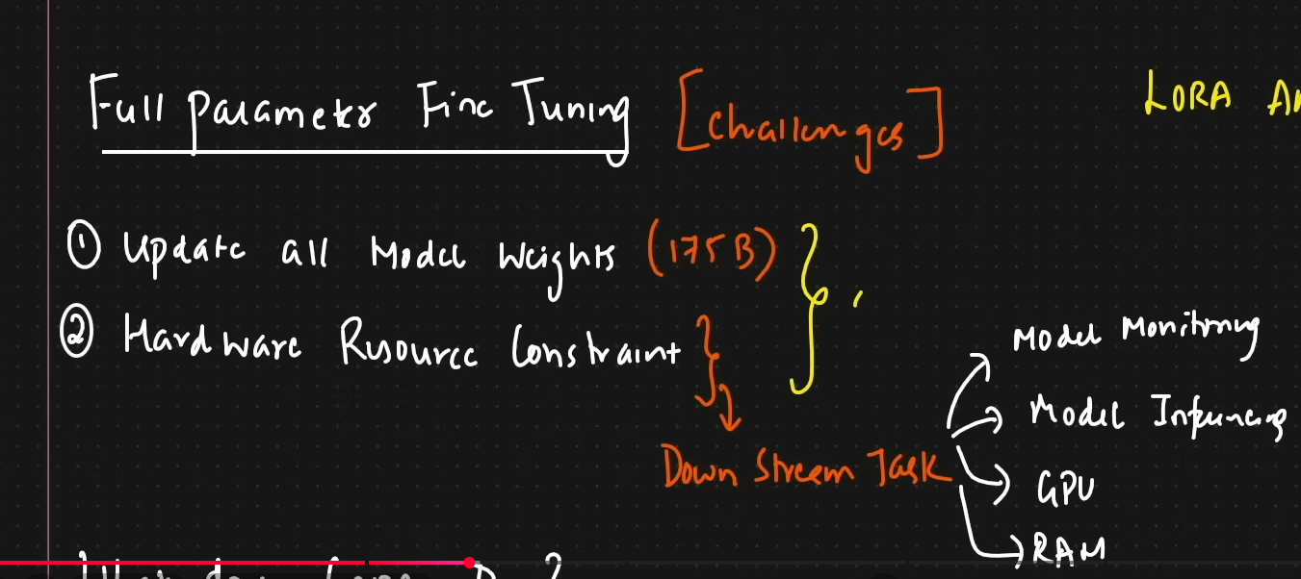
Now in order to do full parameter fine tuning, we can face several challenges such as hardware resources constrain in order to update all the weights of a model. LORA and QLORA helps us in doing that.
WHAT DOES LORA DO?
So in LORA, instead of updating all the weights in a pretrained model, it tracks the changes. Tracks basically the changes of the new weights based on finetuning.
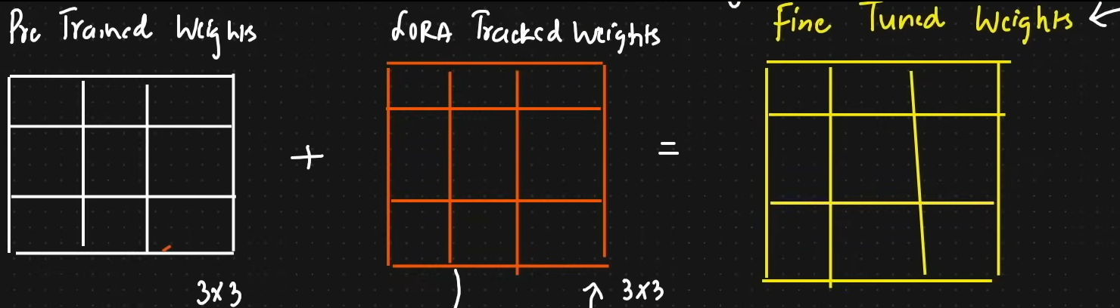
Now, a large model may have billions parameters, normally when finetuning happens a person downloads the model, updates all weights and has to store huge copy. So LORA fixes that by learning a very small adjustment matrix.
You can have:
- coding LoRA
- medical LoRA
- anime-style LoRA
- customer-support LoRA
all on top of the same base model.
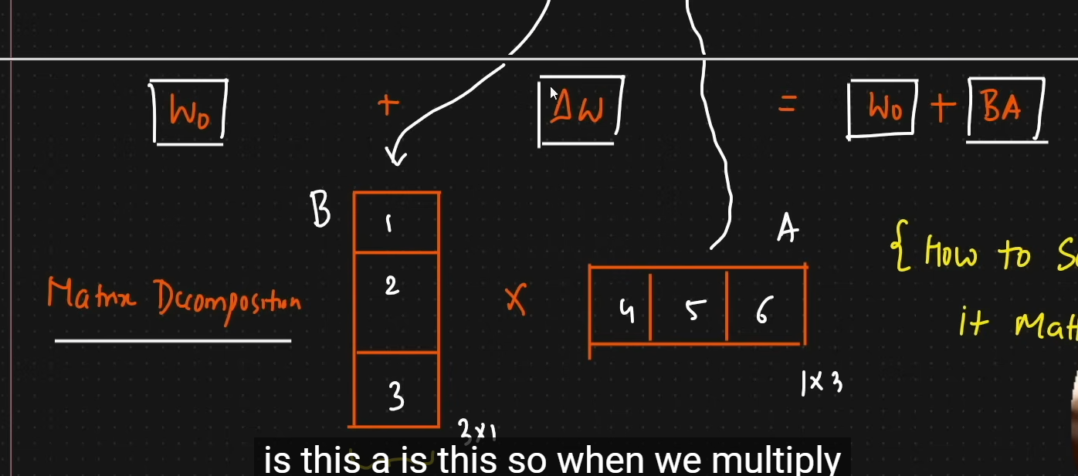

Great question — "rank" is the core concept that makes LoRA work.

What is Rank?
Rank is a concept from linear algebra that describes how much independent information a matrix contains.

Intuition First
Imagine a spreadsheet with 1000 rows and 1000 columns — that's a 1000×1000 matrix.
- If every row is completely unique and independent → high rank
- If many rows are just combinations of a few patterns → low rank
A low-rank matrix looks big but is secretly simple — it can be compressed.

Formal Definition
For a matrix W of size m × n:
- Rank = the number of linearly independent rows (or columns)
- Maximum possible rank = min(m, n)
- If rank << min(m, n), the matrix is low-rank

Simple Example
Matrix A (rank 1):
[ 2 4 6 ]
[ 1 2 3 ]
[ 3 6 9 ]
Every row is just a multiple of [1, 2, 3]. So despite being 3×3, it only contains 1 independent direction → rank = 1.
It can be written as:
A = [2] × [1, 2, 3]
[1]
[3]

(3×1) (1×3) ← two tiny matrices instead of one big one

Why This Matters for LoRA
Neural network weight matrices are huge (e.g., 4096 × 4096 = 16M values).
The key insight behind LoRA is:
The change needed during fine-tuning is often low-rank. You don't need to update all 16M values — the meaningful update lives in a much smaller subspace.
So instead of:
Update W directly → 16,000,000 parameters to train
LoRA does:
W_update = A × B
A: 4096 × r
B: r × 4096

If r = 8: 4096×8 + 8×4096 = 65,536 parameters (~0.4% of original)
r is the rank you choose — a hyperparameter.

Choosing Rank r in LoRA
Rank (r) | Parameters | Use case
1–4 | Tiny | Very simple style/tone adaptation
8–16 | Small | Most common, good balance
32–64 | Medium | Complex task adaptation
128+ | Large | Approaches full fine-tuning
- Lower rank = fewer parameters, faster, may underfit
- Higher rank = more expressive, but more expensive and can overfit

The Core Assumption
LoRA works because of an empirical observation:
Pre-trained models are over-parameterized. The meaningful updates during fine-tuning don't require full-rank changes — the "important directions" live in a low-dimensional subspace.
This has been validated across GPT, LLaMA, Stable Diffusion, and many other models.
In LoRA, rank is the size of the “compressed learning space” used for the adapter.
The easiest way to understand it:
Rank controls how much the LoRA adapter is allowed to change the model.

